First Seizure Pack

One of the aims of the Paediatric Epilepsy Network of NSW is to ensure that children and adolescents who experience their first seizure receive the same high standard of care wherever they live in New South Wales.
The website (www.pennsw.com.au) ensures that standardised, high quality resources are readily available at the point of care to clinicians and families.

Check List for First Seizure

- Information provided to families:
  - General Safety
  - Seizure First Aid
  - Seizure Event Record
  - PENNSW website

- EEG Booked
- Follow up appointment made with General Paediatrician

Safety

We all need to consider safety in our lives. In our day to day living, some activities we undertake are more risky than others. Children and adolescents with Epilepsy have potential other risks that must be considered. By being aware of these risks and minimising them, children with Epilepsy can live full and active lives.

The risk of injury to a child or adolescent with Epilepsy depends upon several factors:
- Type of Seizures: there is increased risk if the seizures cause a loss of consciousness or occur without warning.
- Frequency of Seizures: there is increased risk if there are many seizures per day.
- Seizure Triggers: there are certain activities that can trigger a seizure, such as stress and tiredness.
- Age of child or adolescent.
- Type of Medications being used to control seizures: certain medications, especially at higher doses, can lead to certain side effects such as drowsiness and unsteadiness.
- Type of Activity: always consider the type of activity and the risk posed by having a seizure. Activities such as swimming, surfing, and bike riding are examples.
- Other neurological or health problems.

Safety precautions should be sensible and relevant to the individual child or adolescent.
There needs to be an appropriate balance between risk and restriction.

Your Doctor will be able to give you advice, but safety is a responsibility for all.

Children and adolescents with epilepsy need to especially consider the following activities:

- Swimming:
The pool, open-ocean, surfing and water skiing all pose potential risks to safety. Swimming in a pool with an adult watching closely is not too risky for most children. However, the adult must be prepared to watch the child at all times, be able to swim and assist in a rescue if needed. These precautions apply to school carnivals and swimming sessions, as well as family and teenage outings. Swimming in rivers/dams and surfing or swimming in the open ocean is far more dangerous than swimming in a pool. You always need to consider what you would do if the child were to have a seizure.

- Bathroom and toilets:
In general it is important that your child can not lock themselves into certain rooms in the house. This is so you can gain easy access if they were to have a seizure. Children and adolescents should have showers rather than baths. Your child is very vulnerable while bathing. Never leave your child unsupervised in the bath. The person supervising should be competent in giving first aid (generally an adult and not another sibling).

- Biking:
Wear a helmet when riding a bike. Ride on bike tracks and in parks and not on the road. Main roads, with high car activity, pose the greatest risk.
Medic Alert Bracelets: Consider getting a medic alert bracelet for your child. This is a good way of first aid responders knowing quickly what your child's background history is (especially when you are not there).
Seizure Safety: Epilepsy Action has very good information on Safety. For further information please see:
    - Epilepsy Action: Seizure Smart - Safety (a detailed information sheet on safety).
    - Epilepsy Action: Seizure Smart - Safety Checklist (a thorough checklist which will help you tick off issues around safety once they have been addressed).

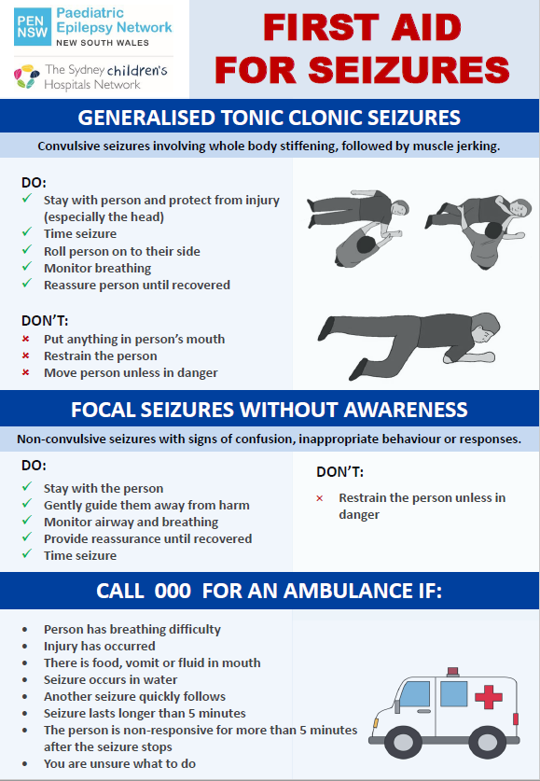

Event Record
This form is to help you collect information about the event(s) causing concern. Show this to your Health Practitioner.
Child / Adolescent: |  |  |  | Date of Birth:
 |  | Event 1 | Event 2
TIP: Capturing future events on video can be helpful for the treating Doctor. Video event IF child is safe.
Who witnessed the episode?
Date and time of episode?
Did you notice anything before the episode?
What was your child doing just before it started? Did anything appear to trigger the episode?
How did the episode start?
Did you notice any change in your child's breathing or colour?
What happened next?
- Was there loss of consciousness?
- Were they able to respond to you?
- Was their body floppy or stiff?
- Did their arms and legs move?
- What did the movements look like?
- Were their eyes open or closed?
- Did their head or eyes jerk or go to one side? Which side?
 |  | Try to note as much other information as you can.
How long did the episode last for, and how did you know it had finished?
What was your child like after the episode, e.g., drowsy, sleepy, aggressive, etc?
How long was it until your child was back to their usual self?
Any other comments?

Paediatric Epilepsy Network NSW

The PENNSW website (www.pennsw.com.au) provides information for children and adolescents living with epilepsy and their families, as well as clinicians involved in patient care. It includes educational resources on the following:
- Seizures explained
- Medicines
- Safety
- Coping with Epilepsy
- Diagnosis
- Emergency Management
- Seizure Plans
- Adolescent resources
- Transition information

